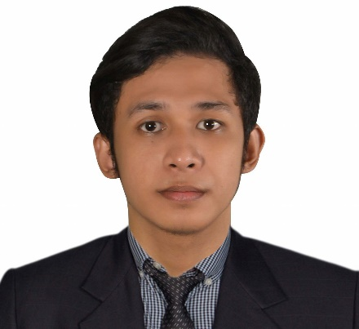

**JAYSON I. TEAÑO**

CONTACT INFORMATION

|  |  |
| --- | --- |
| Email: | teanojay@gmail.com |
| Contact No.: | (+63)936 355 7869 |
| Address: | Section I Block 17 Lot 12 Tropical Village Brgy. San Francisco, General Trias, Cavite Philippines |

OBJECTIVE

To have a job that would enable me to use my talent and skills as well as contribute to organization's goals and which would provide excellent opportunities for career advancement and personal growth.

TECHNICAL SKILLS

* Knowledge in Software Development across multiple platform using different Programming Technologies such as Java (SE, EE and Android), PHP, C# (.Net and Unity3D), VB.Net / VB6, HTML, CSS, JavaScript/TypeScript, XML / JSON and Oracle PL-SQL / MySQL Database.
* Ability to use different Frameworks and Libraries such as Spring, Laravel, SlimPHP, ASP.Net, Angular, jQuery and Bootstrap.
* Ability to use version control using Git and manage dependencies using Maven, Composer and NPM.
* Good understanding in Object Oriented Programming, Design Patterns, REST API and MVC Architectural Pattern.
* Basic knowledge in UNIX, Electronics, Microcontroller Programming, Routing / Switching of Network, Troubleshooting / Repairing Computers, Photoshop and 3D Modelling / Animating.

PERSONAL INFORMATION

|  |  |
| --- | --- |
| Birthdate: | October 15, 1996 |
| Civil Status: | Single |
| Citizenship: | Filipino |
| Gender: | Male |

CHARACTER REFERENCES

*Will be provide upon request.*

EDUCATION BACKGROUND

|  |  |
| --- | --- |
| **National College of Science and Technology**  Course:Bachelor of Science in Computer Science Major Software Development  Address**:** Amafel Building, Aguinaldo Highway, Dasmariñas Cavite | 2015 - Mar. 2018 |
| **Asian Institute of Computer Studies**  Course: Associate in Computer Science  Address**:** Leveriza Bldg., G.E. Aguinaldo Highway, Zone 4, Dasmariñas Cavite | 2013 - 2015 |

PRE-PROFESSIONAL EXPERIENCE

|  |  |
| --- | --- |
| **Member Service II Intern**  Pag-IBIG Fund Dasmariñas MSB  Address**:** 2nd Floor Volets Commercial Building, Emilio Aguinaldo High-way, Dasmariñas City, Cavite | Nov. 20, 2017 - Feb. 22, 2018  360 hours |
| **Programmer Intern**  Provincial ICT Office - Cavite  Address**:** 2nd Floor Provincial Capitol Building, Provincial Capitol Compound, Trece Martires City, Cavite | Nov.18, 2014 - Mar. 24, 2015  300 hours |

RESEARCH / PROJECT PREPARED

* **Three-dimensional (3D) Mobile Application – Based Strategy Game: “The Adventure of Echo – The Little Archaeologist”**

A 3D designed strategy online mobile game concept like Automata Theory with Ads/Analytics Integration, Website and Administrator Tools. (National College of Science and Technology - THESIS).

* **LAN-Based IT Equipment Inventory System**

An Application for Provincial ICT Office of Cavite that helps the company to manage the IT Equipment Inventory. (Asian Institute of Computer Studies - THESIS).

AWARDS AND TRAININGS / SEMINARS ATTENDED

* Most Proficient in Java Programming.
* Best in THESIS for Making LAN-Based Equipment Inventory System for Provincial ICT Office of Cavite.
* ISO 9001:2015 (Quality Management System) Training.
* Basic Android Mobile App Development Training.
* Unity: Creating 3D Games for Beginners Training.
* Web Frameworks using Laravel.
* Game Industry 101.
* How to Land your First Job as a Software Developer & IT Industry.